PCB DESIGN & MANUFACTURING DOCUMENT

Scope of the RC Car Project
The scope of this RC car project is to design, simulate, and implement a remote-controlled vehicle using electronic components and a microcontroller (Arduino). The project focuses on understanding the basic principles of wireless communication, motor control, and embedded systems.
The RC car is intended for educational and demonstration purposes, allowing students to gain hands-on experience in:
- RC vehicle architecture
- Arduino programming
- Motor driver interfacing
- Power supply and control systems
The project scope is limited to short-range control, basic forward/reverse/left/right movements, and low-speed operation. Advanced features such as GPS, camera modules, or autonomous navigation are outside the scope of this project.
- Reduces wiring errors.
- Essential for simulation in Tinkercad / Proteus.
- Acts as official documentation for the project.

Objectives of the RC Car Project
The main objectives of the RC car project are:
- To design and develop a functional RC car using Arduino and electronic components.
- To understand wireless control systems, including transmitter and receiver operation.
- To implement motor control using DC motors and a motor driver module.
- To learn Arduino programming for controlling speed and direction of the vehicle.
- To study power management using batteries and voltage regulation.
- To simulate the circuit and working using tools like Tinkercad before hardware implementation.
- To enhance practical skills in electronics, embedded systems, and troubleshooting.
- To demonstrate real-time control of a moving vehicle using remote commands.
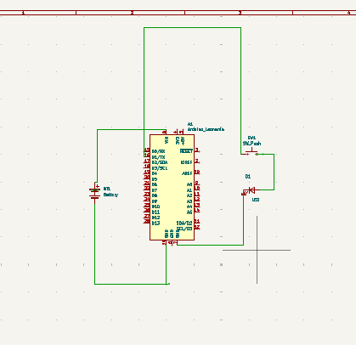

Schematic Explanation
The given schematic represents the control unit of an RC car based on an Arduino board, powered by a battery and connected to external control/output components.

1. Arduino Board (Main Controller)
- The Arduino acts as the brain of the RC car.
- It receives control signals (from RF receiver / Bluetooth / IR – depending on your design).
- Based on the program, it sends output signals to control:
  - Motor direction
  - Motor speed
  - Turning (left/right)
In the schematic:
- Digital pins (D0–D13) are used for control signals.
- Analog pins (A0–A5) can be used for sensor or receiver inputs.
- 5V and GND pins provide power to external modules.

2. Power Supply (Battery)
- A DC battery (typically 7.4V / 9V / 12V depending on motors) is used.
- The battery supplies power to:
  - Arduino (via VIN or regulated 5V)
  - Motor driver circuit
In the schematic:
- The battery positive terminal is connected to the Arduino power input.
- The battery negative terminal is connected to GND.
- Common ground is maintained for proper operation.

3. Output Load (Motor / Indicator Circuit)
- The output side shows a load connected through a diode and resistor.
- This represents:
  - A DC motor, or
  - An indicator LED, or
  - A control signal path to a motor driver module (L298N / L293D)
Diode (D1):
- Protects the circuit from back EMF generated by motors.
- Prevents damage to the Arduino.
Resistor (R1):
- Limits current (especially if an LED is used).
- Ensures safe operation of the output pin.

4. Ground Connection
- All components share a common ground.
- This is essential for:
  - Correct signal reference
  - Stable communication between Arduino and peripherals

Working Principle (Based on the Schematic)
- The battery powers the Arduino.
- The Arduino runs the uploaded control program.
- When a command is received (forward, reverse, left, right):
  - Arduino activates specific output pins.
- These output signals drive the motor control circuit.
- Motors rotate accordingly, causing the RC car to move.

Importance of This Schematic
- Helps visualize hardware connections before building.
- Reduc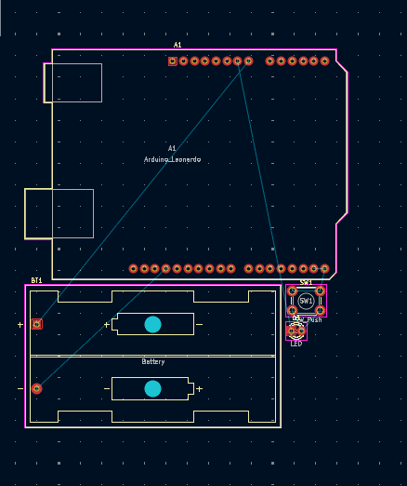es wiring errors.

PCB Layout Placement and Routing

1. Component Placement
Proper component placement is the first and most important step in PCB design.
- Microcontroller (Arduino Leonardo):
Placed at the center/top of the PCB to allow easy access to all input and output pins and to minimize signal length.
- Battery Holder:
Positioned at the bottom of the PCB to provide mechanical stability and to keep high-current power paths short.
- Power Switch:
Mounted near the PCB edge for easy user access and safe power control.
- LED Indicator:
Placed near the power switch to indicate the ON/OFF status of the circuit.
- Connectors and Headers:
Arranged along the edges to simplify external connections and reduce track crossing.

2. PCB Routing
Routing refers to connecting all components using copper tracks.
- Signal Routing:
Thin tracks are used for digital and control signals. Tracks are kept short and direct to reduce noise and signal loss.
- Power Routing:
Wider tracks are used for battery and power supply lines to handle higher current safely.
- Ground Routing:
All ground pins are connected using a common ground plane or wide ground tracks to improve stability and reduce interference.
- Track Angles:
45-degree bends are used instead of 90-degree angles to ensure smooth current flow.

3. Design Considerations
- Adequate spacing is maintained between tracks to avoid short circuits.
- High-current paths are kept away from sensitive signal lines.
- Components are placed logically to minimize routing complexity.
- Design Rule Check (DRC) is performed to ensure error-free layout.

4. Conclusion
Proper PCB layout placement and routing improve circuit reliability, reduce noise, and ensure efficient power distribution. The designed PCB follows standard layout practices, making it suitable for reliable operation of the RC car control system.

1. Footprint Assignment

1.1 Definition
Footprint assignment is the process of linking each schematic symbol to its corresponding physical PCB footprint, which defines the pad size, pad spacing, and component outline.

1.2 Purpose of Footprint Assignment
- Ensures correct physical placement of components on the PCB
- Matches the real component dimensions
- Prevents soldering and assembly errors
- Helps in accurate routing and spacing

1.3 Footprint Assignment Process
- Create or import the schematic diagram
- Select each component and assign a suitable footprint:
  - Arduino Leonardo → Arduino Leonardo PCB footprint
  - Resistors → Axial or SMD footprint (as per component)
  - LED → 3 mm / 5 mm LED footprint
  - Switch → Tactile switch footprint
  - Battery holder → Battery holder footprint
- Verify:
  - Pin count and pin spacing
  - Orientation and polarity marks
- Update schematic to PCB layout

1.4 Importance
- Correct footprint assignment avoids misalignment
- Ensures proper solder joints
- Reduces PCB rework and cost

2. PCB Design Rules (DRC)

2.1 Definition
Design Rule Check (DRC) is an automated verification process that checks the PCB layout against predefined manufacturing and electrical rules.

2.2 Common PCB Design Rules

a) Track Width
- Signal tracks: 0.25 – 0.3 mm
- Power tracks: 0.6 – 1.0 mm

b) Track Clearance
- Minimum clearance between tracks: 0.2 – 0.3 mm

c) Pad-to-Track Clearance
- Ensures no short circuit between pads and tracks

d) Via Size
- Via drill size: 0.3 – 0.4 mm
- Via diameter: 0.6 – 0.8 mm

e) Hole-to-Hole Clearance
- Prevents mechanical and electrical overlap

2.3 Purpose of DRC
- Detects short circuits and open connections
- Verifies manufacturing feasibility
- Ensures safety and reliability
- Confirms compliance with PCB fabrication standards

2.4 DRC Error Types
- Clearance violations
- Unconnected pins
- Track width errors
- Overlapping pads or vias
- Copper too close to board edge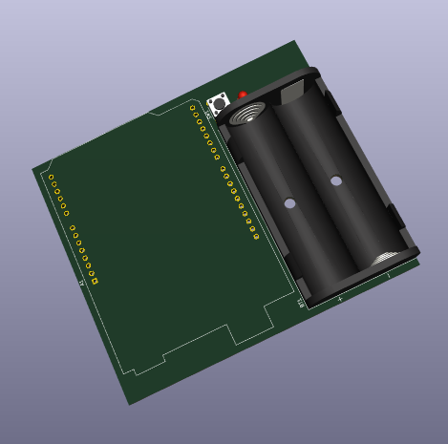

1. 2D PCB View (Top & Bottom Layers)
Aspect | Description
Top Layer View | Shows component placement, copper tracks, pads, and labels
Bottom Layer View | Displays solder pads and routing on the bottom side
Silkscreen | Component names, polarity marks, and reference labels
Copper Tracks | Visual verification of signal and power routing
Board Outline | Confirms PCB shape and mechanical dimensions

2. 3D PCB View
Aspect | Description
Component Height | Ensures components do not clash mechanically
Orientation Check | Verifies correct placement and polarity
Realistic View | Displays PCB as a physical board for visualization
Connector Alignment | Confirms connectors and switches are accessible
Assembly Verification | Helps identify assembly issues before fabrication

3. Final PCB Checks (Before Fabrication)
Check Type | Purpose
Electrical Rule Check (ERC) | Confirms schematic connectivity
Design Rule Check (DRC) | Ensures layout meets manufacturing rules
Footprint Verification | Confirms correct footprints are used
Polarity Check | Verifies LEDs, batteries, and capacitors
Track Width Check | Confirms power and signal trace sizes
Clearance Check | Ensures safe spacing between tracks
Board Edge Clearance | Copper not too close to edges
Unconnected Nets | Ensures no open connections
Silkscreen Readability | Labels not overlapping pads
3D Collision Check | No physical overlap of components

4. Fabrication Readiness
File Type | Purpose
Gerber Files | PCB manufacturing data
Drill File | Hole and via information
DOM | Bill of Materials for components

1. PCB Fabrication Files
File Name | File Extension | Purpose
Top Copper Layer | .GTL | Defines copper tracks on top layer
Bottom Copper Layer | .GBL | Defines copper tracks on bottom layer
Top Solder Mask | .GTS | Openings for soldering on top
Bottom Solder Mask | .GBS | Openings for soldering on bottom
Top Silkscreen | .GTO | Component labels on top side
Bottom Silkscreen | .GBO | Labels on bottom side
Board Outline | .GKO / .GM1 | PCB shape and dimensions
Drill File | .TXT / .DRL | Hole locations and sizes
Drill Drawing | .PDF | Visual reference for drilling

2. PCB Assembly Files
File Name | File Extension | Purpose
Bill of Materials (BOM) | .XLS / .CSV / .PDF | List of all components
Pick and Place File | .CSV / .POS | Component placement for machines
Assembly Drawing | .PDF | Component orientation guide
3D PCB View | .STEP | Mechanical verification
Test Points File | .PDF | Electrical testing reference

Bill of Materials (BOM)
S. No | Component Name | Specification / Value | Quantity | Package / Footprint | Purpose
1 | Arduino Leonardo | ATmega32U4 based board | 1 | Arduino Leonardo PCB | Main controller
2 | DC Motor | 6V / 12V DC Motor | 2 | Motor terminals | Vehicle movement
3 | Motor Driver IC | L293D / L298N | 1 | DIP / Module | Motor control
4 | Battery Holder | 9V / AA battery holder | 1 | Through-hole | Power supply
5 | Power Switch | SPST slide switch | 1 | Through-hole | Power ON/OFF
6 | LED | Red / Green LED | 1 | 3 mm / 5 mm | Power indication
7 | Resistor | 220 Ω / 330 Ω | 1 | Axial | LED current limiting
8 | RF Receiver Module | 433 MHz / Bluetooth | 1 | Module | Wireless control
9 | Antenna | External wire antenna | 1 | Through-hole | Signal reception
10 | Capacitor | 100 µF | 1 | Electrolytic | Power filtering
11 | Jumper Wires | Male–Female | As required | — | Connections
12 | PCB | FR-4, 2-layer | 1 | Custom PCB | Circuit base

